‘Dear Lois’ authors visit New Ulm to share their adoption story
February 14, 2016
By Clay Schuldt - Staff Writer (cschuldt@nujournal.com) , The Journal
Save | Post a comment |
By Clay Schuldt
Staff Writer

NEW ULM - An adoption journey that started in New Ulm brought authors of Karen Schlindwein and Amalie Bowling back town for a book signing at the New Ulm Public Library Saturday morning.

Article Photos
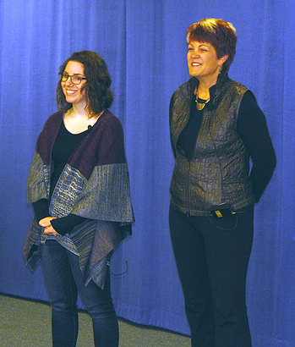
Staff photo by Clay Schuldt

Amalie Bowling (left) and Karen Schlindwein (right) give a presentation on their book “Dear Lois: Our Adoption Journey”. Bowling was adopted by Schlindwein and her husband in 1991. The mother and daughter team co-authored this book on the adoption experience.

The mother/daughter authors self published "Dear Lois: Our Adoption Journey," a non-fiction book that chronicles their family's adoption story.
For Amalie the book tour of New Ulm is something of a homecoming. She was raised in Wisconsin with her adoptive parents, but was born in New Ulm to a woman named Lois. Shortly after she was adopted by Karen Schlindwein and her husband Tom.

Prior to adopting Amalie the Schlindweins' struggled with infertility issues and eventually began searching for adoption opportunities. They eventually became parents after meeting Amalie's birth-mother Lois. A few years later in 1993, the couple adopted a second child, Joseph, from a woman named Ruth. The book tells the story of these adoptions through letters written to birthmothers by adoptive parents as their children grow up.

"We wrote this as means to talk about adoption," explained Schlindwein. "Often times adoption is only depicted from one perspective and this book gives you both sides."

In addition, this book is a way of launching the family's new non-profit organization called "Chosen." Chosen is a group foster child facility and adoption advocacy ministry run by Amalie and her husband Jason. The organization received non-profit status on Dec. 31, 2015 and has already received its first foster placement. A portion of "Dear Lois" will go to funding the Chosen organization.

© Copyright 2016 The Journal. All rights reserved. This material may not be published, broadcast, rewritten or redistributed.

